**BlinkIT Sales Performance Dashboard**

**A Comprehensive Analysis of Sales, Outlets, and Product Trends**

**INTRODUCTION**

The advent of digital technology has transformed the retail landscape, and BlinkIT is a leading player in the online grocery delivery market in India. To remain competitive and make informed business decisions, companies must leverage data effectively. This project aims to design an interactive Power BI dashboard for BlinkIT, enabling stakeholders to analyze sales, item performance, outlet performance, and customer preferences efficiently.

The dashboard consolidates key metrics like total sales, average sales, outlet type performance, and customer ratings, offering actionable insights at a glance.

**OBJECTIVES:**

* To develop an interactive Power BI dashboard that visualizes BlinkIT's key business metrics.
* To analyze and interpret data related to sales performance, outlet types, and customer preferences.
* To enable real-time decision-making by providing comprehensive insights through visual representations.

**TASKS:**

**1. DATA COLLECTION AND PREPARATION:**

Data Sources: The dataset includes sales data, outlet performance, customer ratings, and item details.

Data Cleaning: Removed inconsistencies, null values, and duplicates to ensure data accuracy.

Data Transformation: Used Power Query to reshape and format data for Power BI compatibility.

**2. DASHBOARD DESIGN:**

The dashboard design focuses on providing a clean, intuitive, and interactive user experience. Key sections include:

**Top Metrics Cards:**

* Total Sales: $1.20M
* Average Sales: $141
* Number of Items: 8,523
* Average Rating: 3.9
* Filter Panel: Allows users to filter data by:
* Outlet Location Type
* Outlet Size
* Item Type

**3. KEY VISUALS:**

**Sales Breakdown by Fat Content:** A pie chart shows total sales split between Low Fat and Regular categories.

**Item Type Analysis:** A bar chart highlights sales and average ratings for various product categories, like fruits, dairy, and frozen items.

**Outlet Establishment over Time:** A line chart displays sales trends over the years, indicating peaks and fluctuations.

**Outlet Size and Location Performance:**

* **Outlet Size:** A donut chart categorizes sales as Small, Medium, or Large.
* **Outlet Location:** A horizontal bar chart ranks performance by Tier 1, Tier 2, and Tier 3 locations.

**Outlet Type Comparison:** A table visual compares grocery stores and different supermarket types across metrics like total sales, number of items, average sales, and item visibility.

**4. INSIGHTS DELIVERED:**

**Sales Trends:** Highlighted growth trajectory with spikes in specific years.

**Customer Preferences:** Items with higher ratings and sales (e.g., fruits and snacks) can guide inventory focus.

**Outlet Performance:** Tier 3 outlets outperform others in terms of total sales, emphasizing the importance of expanding in rural or suburban areas.

**Outlet Size Dynamics:** Medium-sized outlets contribute the most to total sales, hinting at scalability opportunities.

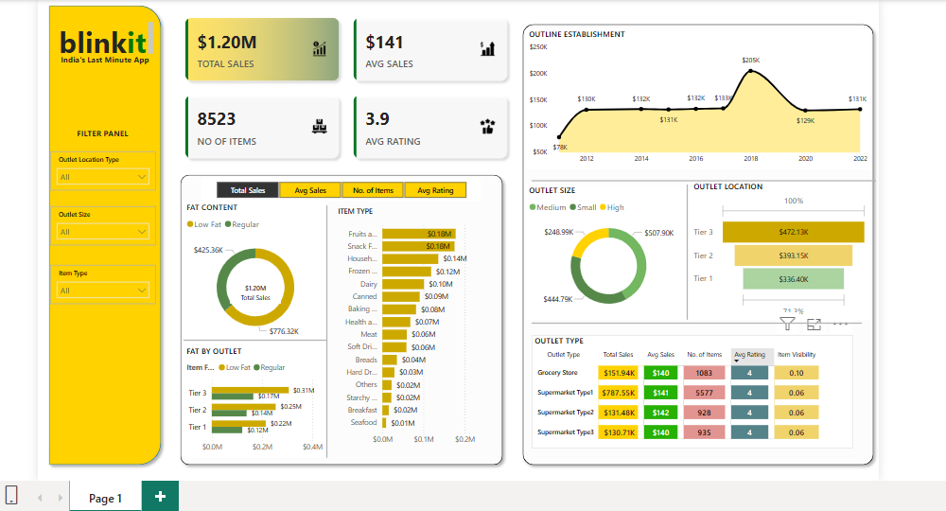

**CONCLUSION:**

This Power BI dashboard successfully consolidates BlinkIT's data into an intuitive and interactive format, allowing stakeholders to identify key performance areas and uncover actionable insights. By leveraging real-time analytics, BlinkIT can optimize inventory management, improve customer satisfaction, and enhance outlet performance.

The project demonstrates the power of data visualization in driving strategic decision-making and highlights how tools like Power BI can transform raw data into meaningful business insights. Future iterations of the dashboard could incorporate additional metrics like delivery times or customer demographics to refine the analysis further.